*Jahangirnagar University*

*Computer networking Lab*

*Lab report 9*



Course Title: Computer Networking laboratory

Course Code: CSE-402

Submitted by:

Name: Md. Omar Faruque Abir

Roll: 44

Submitted Date : 19-12-2019

**Name**: Implementation of mail service.

**Introduction:** Email is submitted by a mail client ([mail user agent](https://en.wikipedia.org/wiki/Mail_user_agent), MUA) to a mail server ([mail submission agent](https://en.wikipedia.org/wiki/Mail_submission_agent), MSA) using SMTP on [TCP](https://en.wikipedia.org/wiki/Transmission_Control_Protocol) port 587. Most [mailbox providers](https://en.wikipedia.org/wiki/Mailbox_Provider) still allow submission on traditional port 25. The MSA delivers the mail to its mail transfer agent ([mail transfer agent](https://en.wikipedia.org/wiki/Mail_transfer_agent), MTA). Often, these two agents are instances of the same software launched with different options on the same machine. Local processing can be done either on a single machine, or split among multiple machines; mail agent processes on one machine can share files, but if processing is on multiple machines, they transfer messages between each other using SMTP, where each machine is configured to use the next machine as a [smart host](https://en.wikipedia.org/wiki/Smart_host). Each process is an MTA (an SMTP server) in its own right.

The boundary MTA uses the [Domain name system](https://en.wikipedia.org/wiki/Domain_name_system) (DNS) to look up the mail exchanger record (MX record) for the recipient's domain (the part of the [email address](https://en.wikipedia.org/wiki/Email_address) on the right of @). The MX record contains the name of the target host. Based on the target host and other factors, the MTA selects an exchange server: see the article [MX record](https://en.wikipedia.org/wiki/MX_record). The MTA connects to the exchange server as an SMTP client.

**Objective:**

We will simulate a mail network with two router consisting of three network where two network consists of server and pc connected with switch. We will send mail form a pc of one network to another pc of different network.

**Network Layout:**

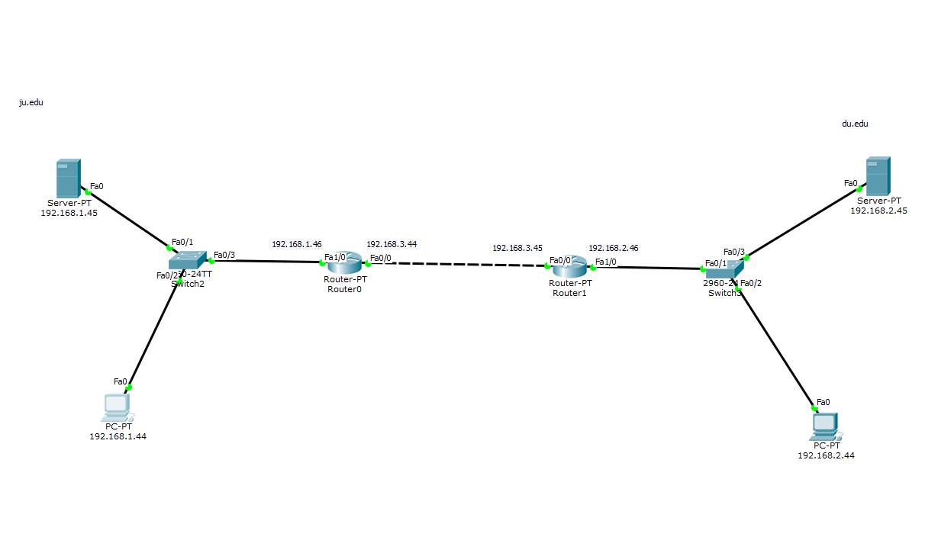

**Configuring servers:**

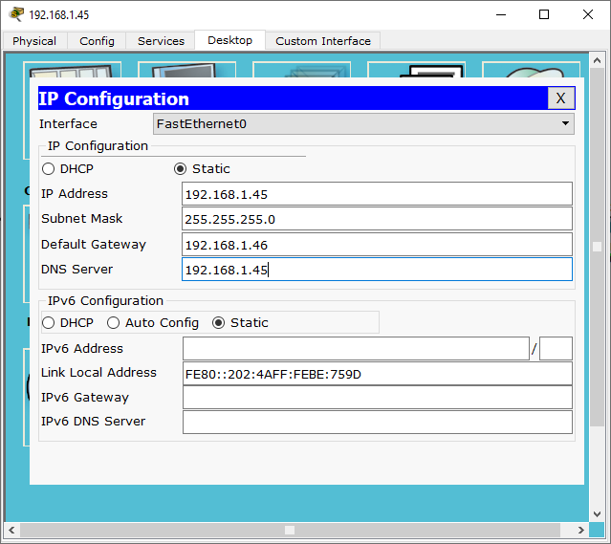

**Configuring router:**

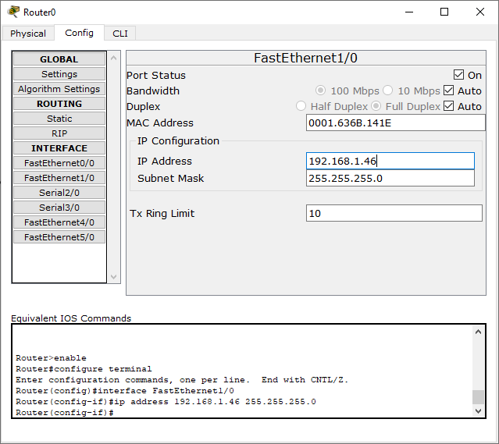

**Configuring Pc:**

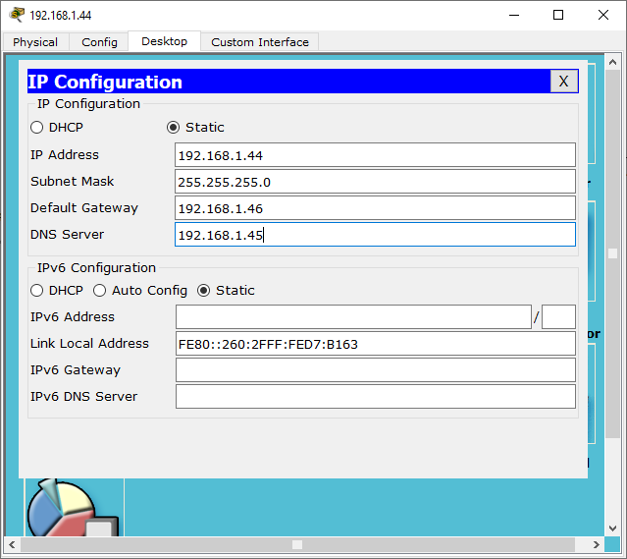

**Other configurations:**

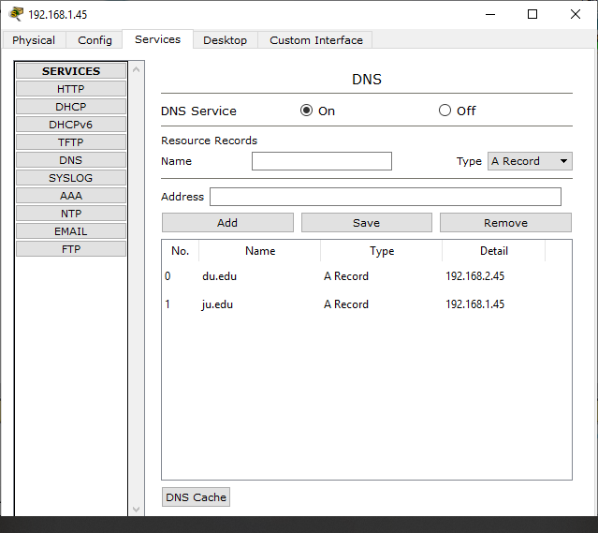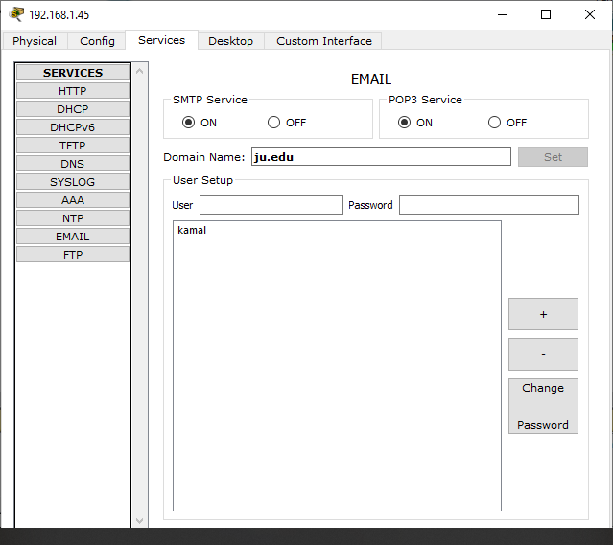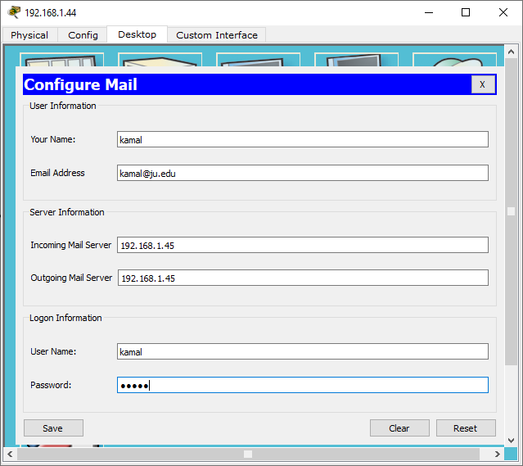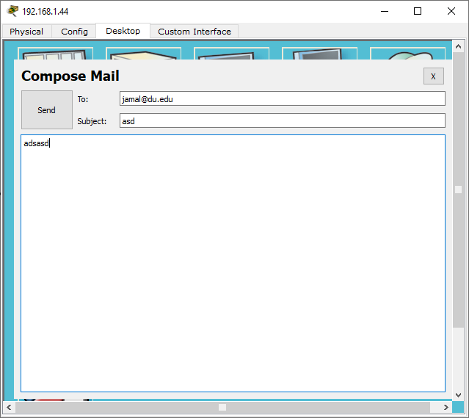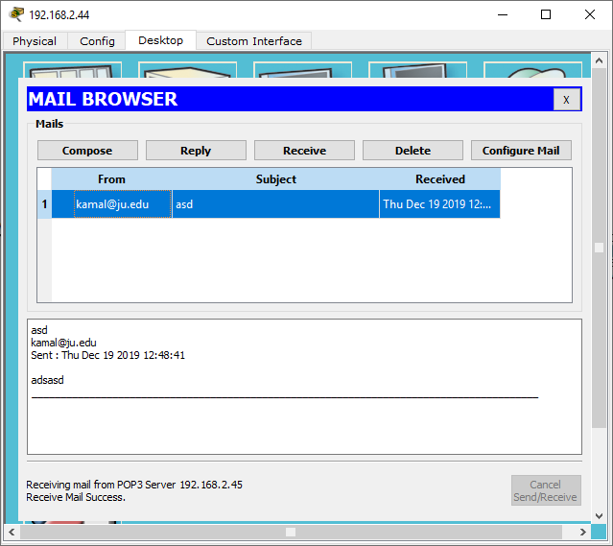

**Conclusion:**

We can clearly observe that Sending mail to another pc is working. So the experiment is a success.